Complex Variable Theory

The importance of the theory of complex variables to linear system theory is that it allows us to formulate signal properties in the inverse time, i.e. frequency, domain and to establish a one to one mapping between the two domains. Many of the transform relations that follow are intimately connected with complex power series expansions and the associated contour integrals. The complex plane is also vital to establishing the stability of an LTI system.

It should not be surprise anyone that there is a natural extension of complex analysis to the multivariable setting which we will not pursue except to say the one may identify Cn with R2n.

Derivative of a Complex Function

The complex derivative at a point z in the complex plane is defined as

provided this limit exists. Note that is a complex number and thus may approach zero in many ways, but the difference quotient () must tend to a unique limit independent of the manner in which approaches zero. This is very different than the real case of standard calculus and imposes a much richer structure on the complex derivative. It is easy to show that functions involving zbar are not differentiable.

Example 2.1
From (), which depends on the slope of the of the approach in which is allowed to go to zero. This limit must be independent of the direction of , and thus the function is not analytic.

Definition 2.1 – A complex valued function w=f(z) is said to be analytic or holomorphic or regular on an open set C if it has a derivative at every point in C.

If z is analytic on the whole complex plane it is said to be entire. All analytic functions may be expressed in terms of z alone. Theorem () in the next section establishes the existence of the Taylor series for an analytic function, thus every analytic function must be expressable interms of z alone, i.e. not including zbar, rex or imz. Analytic functions are a special class of functions.

By applying () in an analogous way for real variate calculus one can show that the standard rules of differentiation hold, in particular the chain rule

and the product rule

By letting the limit approach from two different directions and then equating, one establishes the Cauchy-Reimman equations which are a consequence of the link between the real and imaginary parts of analytic functions.

Cauchy-Reiman conditions

The derivative () may be computed by allowing to approach from any convenient directions in the complex plane. If it approaches horizontally, then dz=dx in (), and we obtain

where

and

On the other hand, if approaches zero vertically, then dz=jdy, and we have

But the right hand members of () and () must be equal to the same complex number f’(z), so by equating real and imaginary parts we see the equations

which are known as the Cauchy-Rieman equations. These equations establish a particular structure on analytic functions.

Definition: CR and continuity are nec and suff for analycity. see page 60 in saff snider.
In order for () to be a stationary point of a real valued function of a complex variable, it is necessary and sufficient for the real derivatives to be zero. However, in the standard case, the derivative form does not reduce the the derivative encountered incomlex variable theory, and for this reason we choose to use another form.

Wirtinger Calculus

Often it is necessary to differentiate real scalar functions of a complex variable. This is especially necessary in optimization theory and we state these results in preparation. Many of the functions in engineering are not analytic and therefore they are not differentiable in the sense of definition (). The standard approach is to differentiate wrt the real and imaginary parts and equate these to zero to find the stationary points. While this method is valid, it has two shortcomings as we shall see : 1) If the function is analytic, the separation method does not reduce to the complex derivative, 2) the separation method requires separation of real and imaginary parts which becomes increasingly cumbersome as the dimension of the function increases. We next develop a generalized derivative operator that is known as the “the derivative trick.”

The real and imaginary parts may be expressed as

Define

.

Using the chain rule applied to a function of two real variables x,y

and similarly for dv/dzstar.

Plugging in to () gives

and hence that

is equivalent to the CR conditions for f in terms of zstar.Therefore, for analytic fuctions, f is independent of zstar and the conjugate partial derivative is zero.

Next, if f is a real valued function of a complex variable, then

By expressing f in terms of z and zstar, we are able to convert the function of two real variables into a real function of two complex variables and thus exploit the existing isomorphism in 1.5 and 1.6.

The function is analytic in z with zstar fixed, and in zstar with z fixed. To see this apply CR.

Once we have showed that the two functions are analytic with things held constant, Based on the ordinary chain rule from calcul we may show

Necessary and sufficient condition for a non-analytic real valued function of a complex random variable (assume real der exist) is for the respective partials of the real and imaginary parts be simultaneously zero.

For the function f to be analytic in zstar, a similar derivation of the CR conditions with yields the CR* equations

. By formally applying the chain rule similar to (1.7), one may show

Thus, in order to be analytic in or equivalently .

For a nonanalytic function of z, the stationary points may still be found be equating the real and imaginary partial derivatives to zero simultaneously, i.e. for a stationary point

. We would like to be able to accomplish this while remaining in the complex domain, without necessitating recourse to separating real and imaginary parts. Using the chain rule we use the isomorphism and

which have unique solution .

By directly applying the chain rule to and using and

and similarly for the conjugate derivative

suggests the operators

Thus since ftilde is analytic the standard rules of complex derivatives apply which simplifies manipulation.

The definitions () and () are good because they reduce to the standard complex derivative even if the function is analytic. The standard approach in most engineering texts is to separate the real and imaginary parts and compute the respective derivatives separately and then combine them as

The process can be cumbersome because it requires the explicit separation into real and imaginary components. Furthermore, if the function is analytic this definition does not reduce to the standard complex derivative defined in complex analysis.

For example is an analytic function with . The approach above gives, for ,

, and thus which is obviously incorrect.

Example 2.2
Suppose we wish to minimize the error cost function , where the error function is parameterized by a complex optimization constant z as
compute. Use the product rule we have

Cauchy’s Integral Theorem

For any function analytic inside and on the positive closed simple contour

Contour parameterizion
Example

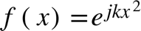

along curve 1, z = 0 to R z=x from 0 to 1.
goes to zero
along curve 2, z = R + iy, y=0 to R,
goes to zero
along curve 3, z = 0 to Rexp(j-pi/4), z = r*exp(j-pi/4) r=0:R, dz = exp(j-pi/4), r
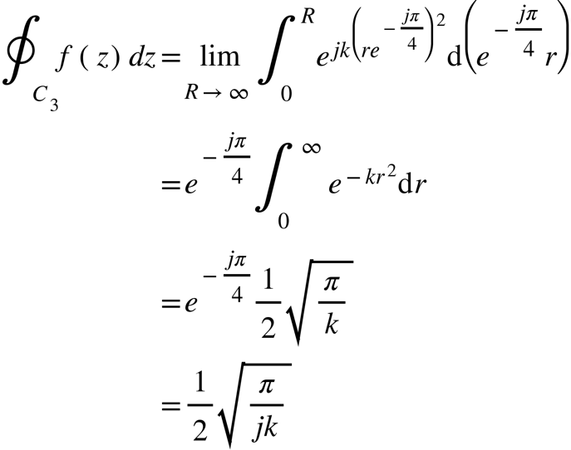

Deformation of Contours

Often in a problem it is easier to evaluate a given quantity over a secondary contour which possesses a simplifying structure. To this end, in the left figure we make a “crosscut” separated by a small dimension. This new region contains no singularities, therefore f is analytic inside and on it and by CIT the contour integral is zero.

In the limit asgoes to 0, the line paths andcoincide as opposites and sum to zero so that

We then have the result

which says that if an outer contour is deformed into an inner contour to create a simply connected region, then the value of the integral over remains unchanged.
The consequence is that the shape of the contour is immaterial to the outcome of the integral as long as f(z) is analytic in the crosscut region.

Integration of complex polynomials

If the center of the inner circle is taken to be at any point in the complex plain alpha, then the deformation principle shows that the integral of any contour enclosing alpha is equal to an integral over the unit circle. The complex polynomial is an important function, so let us compute over any contour C enclosing. The integral is evaluated over a unit radius circle with center to yield

where the integral is accomplished by noting is for .

Cauchy’s Integral Formula

Cauchy’s integral theorem establishes that as long as there are no singularities enclosed in a region, the path integral around the region is zero. However, what if the region encloses one or more isolated singularities?

Let C be a simple closed contour where is analytic, letbe inside C. Also, let be a small circle of radiusaround . The function is analytic everywhere except at . However, after making a crosscut is analytic in between C and so that by CIT

In the limit as , so that

which is known as Cauchy’s Integral Formul (CIF). This formula may be used to evaluate the contour integral described in figure ().

The middle step in is by CIT and the last step is by CIF.

Cauchy’s Residue theorem

If the Laurent expansion of the function is known, then contour integrals may be evaluated by summing the residues. Suppose as in Figure 2 that C surrounds n singularitieswhich are of order. Then by CIT

So that we need only evaluate on the circles defined by for . The function is analytic in and on and hence may be expanded in the series

Integrating term by term yields

By the only term that survives is the term so that

hence,

The coefficient of the series that survives, , is known as the residue of at . By differentiating times and evaluating a at so that all terms vanish except for the term, we arrive at the following formula for the residue of an ^{th} order pole

